Leveled Problems HS. #9 (HSF.IF.B.4), #10 (HSA.REI.C.6), Free response #4 (HSA.CED.A.2, HSA.REI.B.4a, HSA.REI.C.6) , Free response #5 (HSF.IF.B.4)
Level 1 Question 9.1.2

Name the point that is the:

a) maximum? ________ b) minimum? ________

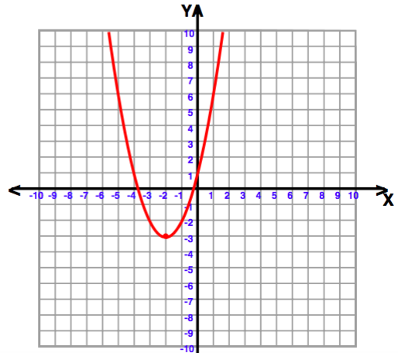
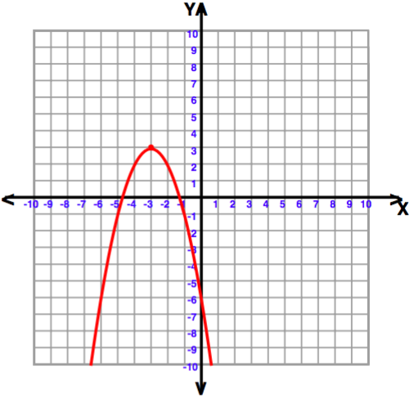

Level 2 Question 9.2

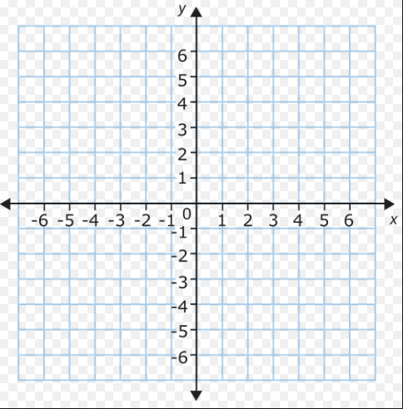
Use the equation y = x² + 1 to complete the table. Draw a graph of the equation on the coordinate plane.

x | y
2
1
0
-1
-2

Level 3 Question 9.3

Use the equation y = (x+2)² -4 to complete the table. Draw a graph of the equation on the coordinate plane. Find the ordered pair that is the lowest point or minimum on the graph.

Ordered pair of lowest point (_____, ______)

x | y
-4
-3
-2
-1
0

Level 4 Question 9.4
In the function y = -(x + 2)² + 3 the maximum value occurs when x is
- 0
- -1
- -2
- -3

Level 1 Question 10.1
The (x,y) coordinates where the 2 lines intersect are:

a) (____, ____) b) (____, ____)

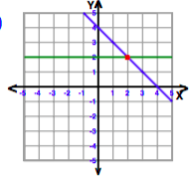
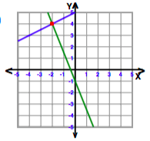

Level 2 Question 10.2
Complete the table and graph for the equation y = 3x + 2
The slope of the line = _______

The line crosses the y-axis at _______

x | y
1
0
-1

Level 3 Question 10.3
Graph the equations y = 2 and y = -x + 4
The (x,y) coordinates where the 2 lines intersect are (____, ____) .

x | y
x | y

Level 4 Question 10.4
What is the x-coordinate of the point of intersection for the two lines given below?
3x + 2y = 2
-x + 2y = -3

  - 2
  - 1
  - -1
  - -2

Level 1 Free Response Question 4.1
90 meters of fencing is being used as the perimeter of a rectangular garden. The length of the garden is 30 meters long. Find the width of the garden. Label the length and width on the picture. Show your work needed to find the width.

Length = 30 meters

Width = _______ meters Width = ______ meters

Length = 30 meters

Level 2 Free Response Question 4.2
A contractor has 120 meters of fencing that he is going to use as the perimeter of a square garden. The length of one side of the garden is represented by x. Draw a picture of the garden and label the sides. Determine, algebraically, the dimensions of the garden in meters. Find the area of the garden.

Length = ___________meters

Width = ___________meters

Area = ____________ square meters

Level 3 Free Response Question 4.3
A contractor has 108 meters of fencing that he is going to use as the perimeter of a rectangular garden. The length of one side of the garden is represented by x and the width of one side of the garden is represented by 2x. Draw a picture of the garden and label the sides. Determine, algebraically, the dimensions of the garden in meters and find the area of the garden.

Level 4 Free Response Question 4.4
A contractor has 54 meters of fencing that he is going to use as the perimeter of a rectangular garden. The length of one side of the garden is represented by x, and the area of the garden is 126 square meters. Determine, algebraically, the dimensions of the garden in meters.

Level 1 Free Response Question 5.1
Let y = x²
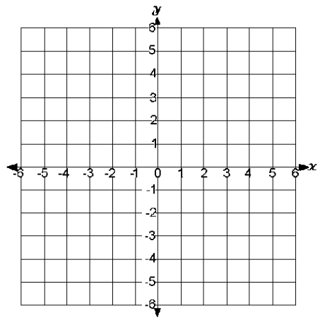
Complete the table. Plot the 5 points on the coordinate plane. Draw in the graph of the equation.
x | y
2
1
0
-1
-2

Level 2 Free Response Question 5.2
Let y = x² - 5

a) Complete the table. Plot the 5 points on the coordinate plane. Draw in the graph of the equation.
x | y
2
1
0
-1
--2

b) In the table, between which x values do the y values decrease? ___________ and ____________

Level 3 Free Response Question 5.3
Let h(t)= -3t² + 18t represent the height of an object above the ground after t seconds.
Determine the number of seconds it takes to achieve its maximum height. Justify your answer.
# of seconds to reach maximum height = _________________
t | h(t)

Level 4 Free Response Question 5.4
Let h(t) = -16 t² +128t +144 represent the height of an object above the ground after t seconds.

Determine the number of seconds it takes to achieve its maximum height. Justify your answer.
State the time interval, in seconds, during which the height of the object decreases. Explain your reasoning.

