F.IF.B.4 Average Rate of Change
Average Rate of Change (Grade Level) | Given the function f(x) = 2x^2 + 3x, calculate the average rate of change from x = 1 to x = 4.
Average Rate of Change (7th Grade) | The table shows the values of a function: x: 0, 2, 4; f(x): 1, 5, 13. Find the average rate of change from x = 0 to x = 4.
  x | f(x)
  0 | 1
  2 | 5
  4 | 13
Average Rate of Change (5th Grade) | A car travels 60 miles in 2 hours. What is the average rate of change in miles per hour?
Average Rate of Change (3rd Grade) | A plant grows from 10 cm to 18 cm in 4 days. What is the average growth per day?
F.IF.B.4 & 6 Leveled Tasks: Average Rate of Change and Graphing a Quadratic Function Using a Table
F.IF.B.6 Graphing a Quadratic Function Using a Table
Graphing a Quadratic Function Using a Table (Grade Level) | 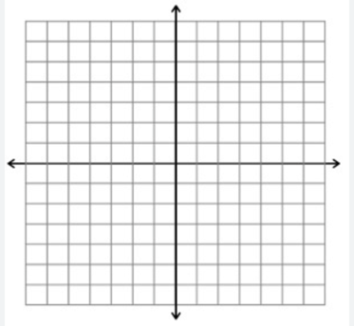  Given the function f(x) = x^2 - 4x + 1, complete the table for x = 0, 1, 2, 3, 4, 5, then plot the points and graph the function.
  x | f(x) = x^2 - 4x + 1
  0
  1
  2
  3
  4
  5
Graphing a Quadratic Function Using a Table (7th Grade) | Given the function f(x) = x^2, fill in the table for x = -2, -1, 0, 1, 2, and plot the points on a graph.
  x | f(x)
  -2
  -1
  0
  1
  2
Graphing a Quadratic Function Using a Table (5th Grade) | Given the function f(x) = x^2 for x = 0, 1, 2, complete the table and draw the points on a graph.
  x | f(x) = x^2
  0
  1
  2
Graphing a Quadratic Function Using a Table (3rd Grade) | 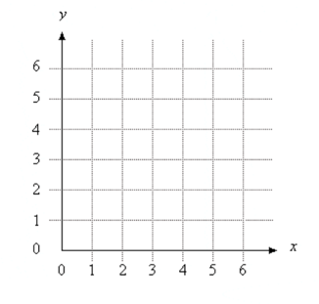  Here is a table for y = x^2 with x = 0, 1, 2. Fill in the missing y-values and draw the points on a simple grid.
  x | y = x^2
  0
  1
  2

