Proving Vertical Angles Are Congruent (Grade Level) | Given two intersecting lines forming vertical angles, write a formal proof to show that the vertical angles are congruent.  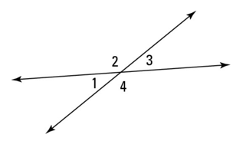
Explaining Vertical Angles (7th Grade) | Explain why the angles opposite each other when two lines cross are always equal.
Identifying Vertical Angles (5th Grade) | Look at the diagram of two crossing lines. Which pairs of angles are vertical angles? Are they the same size?
Recognizing Equal Angles (3rd Grade) | When two lines cross, some angles are across from each other. Are these angles the same?
G.CO.C.9 Leveled Tasks: Proving Vertical Angles Congruent

G.CO.C.9 Leveled Tasks: Proving Alternate Interior Angles Are Congruent
Proving Alternate Interior Angles Are Congruent (Grade Level) | Given two parallel lines cut by a transversal, write a formal proof to show that alternate interior angles are congruent.  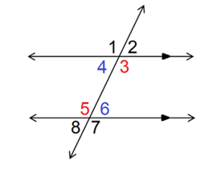
Explaining Alternate Interior Angles (7th Grade) | Explain why the angles on opposite sides of a transversal and inside two parallel lines are always equal.  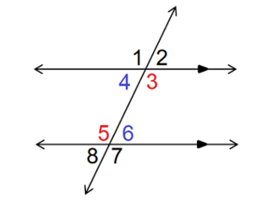
Identifying Alternate Interior Angles (5th Grade) | Look at the diagram of two parallel lines cut by a transversal. Which pairs of angles are alternate interior angles? Are they the same size?  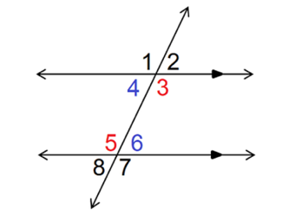
Recognizing Equal Angles (3rd Grade) | When a line crosses two other lines, some angles are across from each other inside the lines. Are these angles the same?  